Garbage Collector Lab
Student ID _____________________
Student Name _____________________
Start Time ________________________
Finish Time ________________________

Introduction
In this lab you will be writing a conservative mark-and-sweep garbage collector for C programs.

Read the lab instruction (gc-lab-instruction.pdf) carefully.

Submit：
- garbage_collector project folder with your implementation
- a report to describe the detail of implementation.

运行环境：VS2022
关闭随机基址、安全检查、SafeSEH和DEP，禁用优化
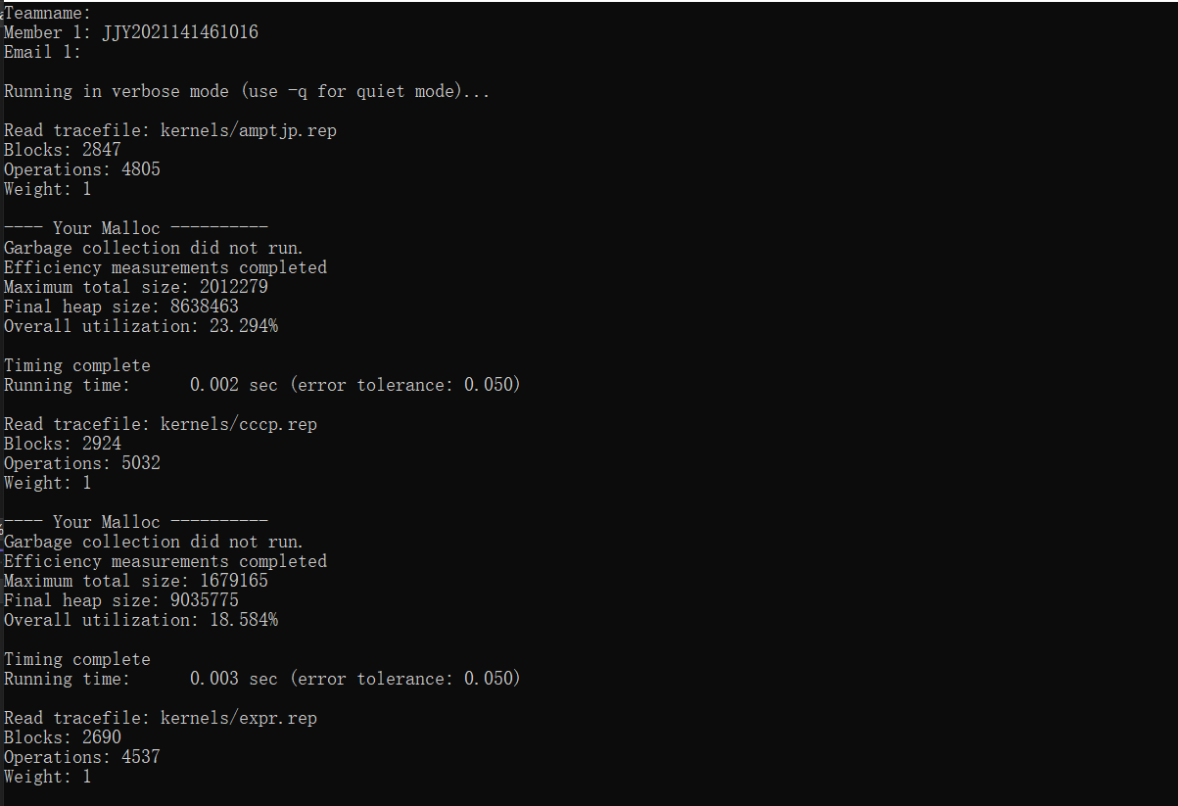
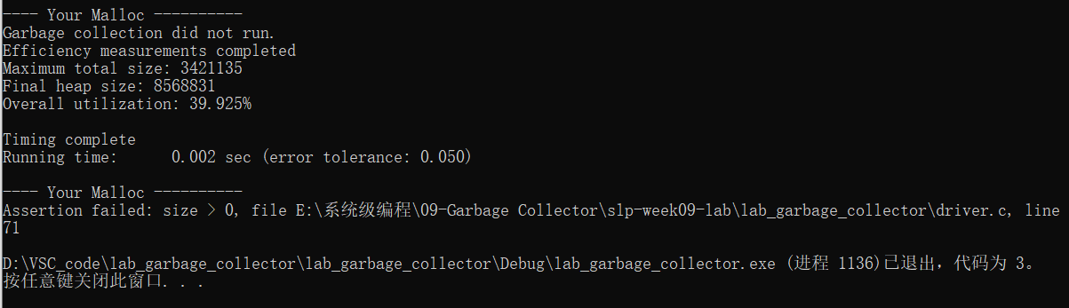

//参考资料（这个实验我看不懂😇）
//https://github.com/VicentChen/garbage-collection-lab/tree/master

